Final Report
Conserving Cambodia's marine mammals: a nationwide bycatch assessment and initiation of a marine mammal bycatch and stranding network
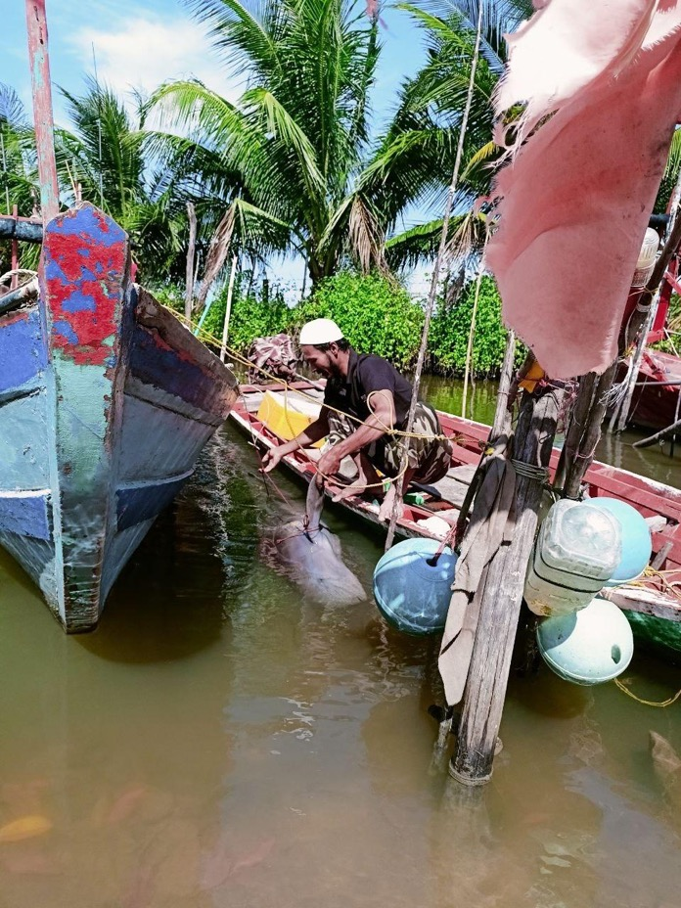

Report compiled by Rose Ellis Arnett, Chhayhy Heng and Sarah Tubbs (2025)

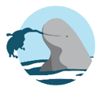

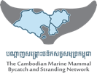





Project Summary
In Cambodia, understudied and threatened marine mammal species face intense threats from fisheries bycatch. The current project (i) used fisher questionnaires to investigate species- and fishery-specific bycatch rates throughout Cambodia, and (ii) launched a nationwide bycatch and stranding network to further understand and monitor bycatch over time. Knowledge gained will be used to support the development of fishery policy and inform future conservation action to safeguard the species.

Funders | NOAA Grant #NA20NMF0080322 to the Consortium for Wildlife Bycatch Reduction at Ocean Associates
Collaborators | Newcastle University, Cambodian Fisheries Administration (FiA), SAMAKY Organization, Mlup Promviheathor Center
Start date | August 2023
End date | January 2025
Total funds received | 31,820.00 USD
Funds spent | 31,811.12 USD
Funds remaining | 8.88 USD
Project leads | Sarah Tubbs, Rose Ellis Arnett
Project team | Chhayhy Heng, Lokkaman El, Nathan Nop, Hanafy Res, Rith Khang, Dararoth Ke

Contents

Project Summary 2
1. Phase I: using fisher questionnaires to investigate species- and fishery-specific bycatch rates throughout Cambodia. 5
2.1. Introduction 5
2.2. Methods 5
2.3. Results 5
2.4. Conclusion 6
2.5. Next steps 6
2. Phase II: launching a nationwide bycatch and stranding network, to further understand and monitor bycatch over time 7
3.1. Introduction 7
3.2. Methods 7
3.3. Results 8
3.4. Conclusion 8
3.5. Next steps 8
3. Conclusion 8
4. Acknowledgements 9
5. References 10

1. Phase I: Using fisher questionnaires to investigate species- and fishery-specific bycatch rates throughout Cambodia.

1.1. Introduction
Bycatch is recognised as the greatest threat to marine mammals globally (e.g. Avila et al., 2018; Read et al., 2006). Coastal marine mammals face intense bycatch threats due to the overlap of their habitat with humans. Lack of knowledge on the extent of bycatch threats in developing countries often hinders the tailoring of bycatch mitigation strategies. Cambodia’s coastal waters support populations of three threatened cetacean species and one sirenian species: the Irrawaddy dolphin (Orcaella brevirostris; EN), the Indo-Pacific humpback dolphin (Sousa chinensis; VU), the Indo-Pacific finless porpoise (Neophocaena phocaenoides; VU) and the dugong (Dugong dugon; VU) (Jefferson et al., 2017; Minton et al., 2017; Wang and Reeves, 2017; Tubbs et al., 2019; Tubbs et al., 2020). The current project seeks to use fisher questionnaires to investigate species and fishery-specific bycatch rates throughout Cambodia.

1.2. Methods
To estimate country-wide annual bycatch rates for the focal species, questionnaires were designed following bycatch questionnaire design methods suggested by Tubbs and Berggren (2024). A total of 449 interviews were conducted with fishers from 39 communities across Cambodia’s coastline between September – November 2023. Photographs of fieldwork can be found in Appendix A. Communities were selected using cluster sampling. Fishers within communities were selected using opportunity sampling as no fisher lists were available. All interviewed fishers used gillnets, traps, lines (long line or hook and line), trawls or seine nets. Interviews lasted around 10 minutes. To reduce knowledge bias and increase confidence in fishers’ responses regards species-specific bycatch, each interviewee was presented with images of the focal dolphin species and asked to identify which species they were familiar with. Only if an interviewee was familiar with a species, were they asked bycatch specific questions regards the species. However, it is possible knowledge bias was still present. In the future, such knowledge bias could be further reduced by providing fishers with species identification training, such as was conducted in phase II of this project. The question used to ask fishers about bycatch was ‘How many individuals of [insert species name] were caught in your fishing gear in the one-year period between September 2022 – August 2023?’. Fishery effort data was attained from the Cambodian 2018 Fishing Vessel Census. Ratio- and model-based approaches were used to estimate Irrawaddy dolphin bycatch. Model-based approaches involved fitting hurdle models to bycatch presence-absence and count data as a function of socio-demographic, location and fishing characteristic covariates. Predictions were made from fitted models. After evaluation of model- and ratio-based methods, model-based methods were selected to produce final Irrawaddy dolphin bycatch estimates. Ratio-based methods alone were used to estimate bycatch for the remaining species.

1.3. Results
Annual country-wide bycatch of 755 Irrawaddy dolphins (95% CI 732-777), 60 humpback dolphins (95% CI 4-144), 101 finless porpoises (95% CI 6-201) and 7 dugongs (95% CI 0-21) were estimated. The Koh Kong gillnet fishery was found to contribute most to Irrawaddy dolphin bycatch (253 animals/year, 95% CI 246-261), whereas the Sihanoukville trawl fishery was found to contribute most to humpback dolphin and finless porpoise bycatch (29 dolphins/year 95% CI 1-87 and 87 finless porpoise/year 95% CI 3-173, respectively). All reported dugong bycatch occurred in the Kep and Kampot trawl fishery.

1.4. Conclusion
This study produced the first bycatch estimates for Irrawaddy dolphins, humpback dolphins, finless porpoises and dugongs for Cambodia’s maritime waters, and some of the first for the species, worldwide. The study identified that Irrawaddy dolphins had the highest annual bycatch of the study species, closely followed by the Indo-Pacific finless porpoise. Given the conservation concerns and statuses of the study species, the bycatch rates observed in this study are likely unsustainable. The identified fisheries should be the focus of bycatch mitigation efforts that work to reduce species bycatch and support species conservation. Cooperation is needed between researchers, decision-makers and fishers to ensure the success of any implemented mitigation measures.

1.5. Next steps
The work from phase I was presented at the Society of Marine Mammalogy’s 2024 Conference in Perth (Appendix B). The work of this phase is currently being prepared for submission to a high-ranking peer-reviewed journal. We therefore request that this document is not shared externally.

2. Phase II: launching a nationwide bycatch and stranding network, to further understand and monitor bycatch over time

2.1. Introduction
Stranding and bycatch networks can be utilised to gather long-term, low-cost bycatch data sets that can be used to track bycatch over time and validate interview results (Saxena et al., 2022). Network data can be used to monitor and understand the abundance, distribution, health and other threats confronting marine mammals in Cambodia. Further, networks work as a method to mobilise community members and fishers, strengthening relationships between them and marine mammals. For these reasons, The Cambodian Marine Mammal Bycatch and Stranding Network (CMMBSN) was launched. The CMMBSN is the only project of its kind in Cambodia. Collected data will be crucial for developing future research-led conservation plans and marine mammal bycatch mitigation strategies. Building stronger connections between community members and marine mammals will also help foster support for bycatch mitigation measures.

2.2. Methods
Technical training on marine mammal bycatch and strandings was provided to 35 fishing communities, which include 61 villages. Covering all four coastal provinces (Kep, Kampot, Sihanoukville and Koh Kong), 24 training sessions were conducted, training a total of 285 community members and 28 FiA officers. The community committee members were specifically chosen for this technical training as they are elected representatives of their community and, along with the chief, they already play an active role in their community and are well-known among villagers and fishers. Two Lead Community Responders (LCRs) from each community, 70 in total, were chosen to be ambassadors of the CMMBSN (Appendix B). These LCRs would be the primary point of contact between KOL and the community. Each community was provided with one backpack, which had all equipment needed to respond to bycatch and stranding events. The LCRs were responsible for this equipment. Including fisheries officers in the training was essential as, despite knowledge gaps, the FiA works closely with fishing communities and responding to bycatch or stranding events is part of their delegated responsibilities. Their presence helped solidify the CMMBSN and lends to a more sustainable network for the future.
The training included an introduction to marine mammals, their threats, bycatch and stranding definitions, why the network is important, species ID, sex determination, key measurements needed, how to identify evidence of bycatch, and how to take scientific photographs. The training booklet can be found in (Appendix B). To help spread awareness, the LCRs were given posters with information and their contact details on, stickers to spread around their community, a Facebook page was launched (បណ្តាញសង្គ្រោះថនិកសត្វសមុទ្រកម្ពុជា), and all community members and FiA officers were invited to a Telegram group. When LCRs report a bycatch or stranding event, they are paid 5$ for each report they make and a 1$ phone top-up.
2.3. Results
Since the launch of the CMMBSN, there have been a total of two marine mammal bycatch reports and seven strandings reports. Bycatch reports include an Indo-Pacific finless porpoise, reported by an LCR from Trapaeng Ropov Fishing Community on 9th June 2024 (Appendix B). Stranding reports include a dugong reported by an LCR from Kampong Tralach Fishing Community in Kep on 13th July 2024 (Appendix B). The dugong carcass was decomposed limiting data collection. However, LCRs were able to take two teeth samples for further study. During an Irrawaddy dolphin stranding on 13th August 2024 at Prey Nob Two Fishing Community, LCRs identified the individual as a female measuring 2.2m in length and weighing 70kg, with some evidence of bycatch around the head (Appendix B).
The CMMBSN Facebook page has 773 followers and 618 likes and the Telegram group has 161 active members.
In November 2024, team members from Khmer Ocean Life presented project results at the Society of Marine Mammalogy Conference in Perth (Appendix B).

2.4. Conclusion
The Cambodian Marine Mammal Bycatch and Stranding Network (CMMBSN) has made significant strides since launching and the LCRs have been successfully reporting data on marine mammal bycatch and stranding events. All reports contribute valuable information to our understanding of marine mammals in Cambodia. This data helps confirm the presence of these species in Cambodian waters and provides a basis for future conservation plans and research. Overall, the early success of the CMMBSN highlights the importance of community involvement and effective technical training.

2.5. Next steps
The next steps should be focused on spreading awareness and further training. Outreach events in coastal villages would help increase fisher knowledge and bycatch and stranding reports for their LCRs. LCRs and fisheries officers would benefit from further training to solidify their technical skills, ensure the data's reliability, and continue their engagement with the network. Further community training on necropsies and live strandings would also benefit the network, leading to more data on threats and saving more marine mammals’ lives.

3. Conclusion
The funded two-part project (“Conserving Cambodia's marine mammals: a nationwide bycatch assessment and initiation of a marine mammal bycatch and stranding network”) has collected valuable data on the bycatch of Cambodia’s threatened marine mammal species. Bycatch estimates were produced and problem fisheries were identified. The current project has also worked to strengthen partnerships between Khmer Ocean Life, government groups and communities. The intel provided by the project will help inform the next steps for marine mammal bycatch mitigation in Cambodia. Specifically, the project has identified fisheries and communities to work with to run bycatch mitigation trials. In 2025, Khmer Ocean Life will lead another two-part project that will (i) work with local and international stakeholders to design a Bycatch Mitigation Action Plan for marine mammals in Cambodia, and (ii) trial pingers as a bycatch mitigation strategy. The relationships strengthened during the current project will prove invaluable moving forward with effective marine mammal research and conservation initiatives in Cambodia.

4. Acknowledgements
We are especially grateful to our local partner SAMAKY Organization, all the fishers who participated in the questionnaire study and all community members and Fisheries Administration officers involved in the CMMBSN. Thank you to ORRCA and the United Kingdom Cetacean Strandings Investigation Program (UKCSIP) for valuable discussions regarding the design and launch of the CMMBSN. A big thank you also to Khmer Ocean Life and SAMAKY staff (Dararoth Ke, Lokkaman El, Nathan Nop, Aing Kim Ok, Josh Arnett, and Sivorn Sat) and other interview team members (Hanafy Res, Rith Khang) for your valuable contribution to data collection and project support.
Finally, thank you also to the funders, the Consortium for Wildlife Bycatch Reduction, Ocean Associates and NOAA for funding this project and making this work possible.

5. References
Avila, I.C. et al. 2018. Current global risks to marine mammals: Taking stock of the threats. Biological Conservation. 221: 44–58.

Jefferson, T.A. et al. 2017. Sousa chinensis (errata version published in 2018). The IUCN Red List of Threatened Species 2017: e.T82031425A123794774. https://dx.doi.org/10.2305/IUCN.UK.2017- 3.RLTS.T82031425A50372332.en. Accessed on 22 November 2022.

Minton, G et al. 2017. Orcaella brevirostris (errata version published in 2018). The IUCN Red List of Threatened Species 2017: e.T15419A123790805. Accessed on 12 December 2023.

Read, A. et al. 2006. By-catches of marine mammals in U.S. fisheries and a first estimate of global marine mammal by-catch. Conservation Biology, 20: 163-169.

Tubbs, S. et al. 2019. Sighting and stranding reports of Irrawaddy dolphins (Orcaella brevirostris) and Dugongs (Dugong dugon) in Kep and Kampot, Cambodia. Aquatic Mammals. 45: 563–568. https://doi.org/10.1578/AM.45.5.2019.563

Tubbs, S., et al. 2020. On the distribution, behaviour and seasonal variation of Irrawaddy dolphins in the Kep archipelago, Cambodia. Raffles Bulletin of Zoology, 68: 137-149.

Wang, J.Y. and Reeves, R. 2017. Neophocaena phocaenoides. The IUCN Red List of Threatened Species 2017: e.T198920A50386795. https://dx.doi.org/10.2305/IUCN.UK.2017-3.RLTS.T198920A50386795.en. Accessed on 22 November 2022.
Saxena, A. and Chatterjee, S. (2022) Public-Private Partnerships for Achieving the SDGs: A Case Study of the Marine Stranding Network in Goa, India. Sustainable Development Goals Series [online]. pp. 95–106. [Accessed 2 January 2023].

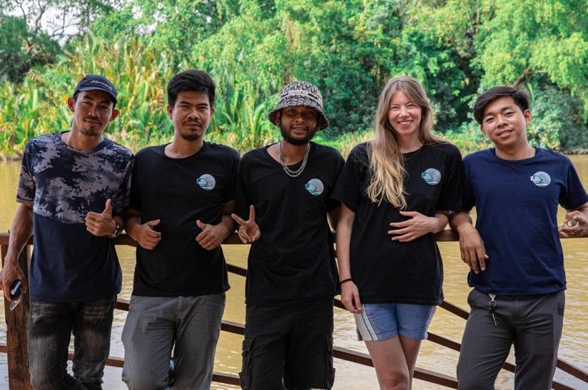
Appendix A
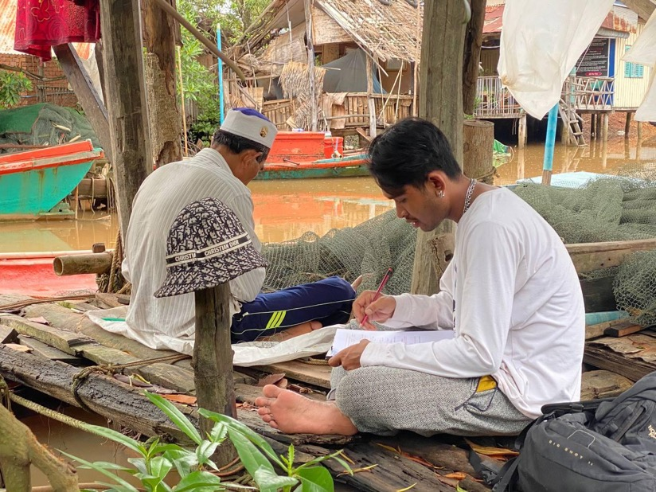
The bycatch interview team, from left to right: Lokkaman El, Rith Khang, Nathan Nop, Sarah Tubbs, Hanafy Res
A bycatch interview being conducted with a fisher in Kampot Province, Cambodia
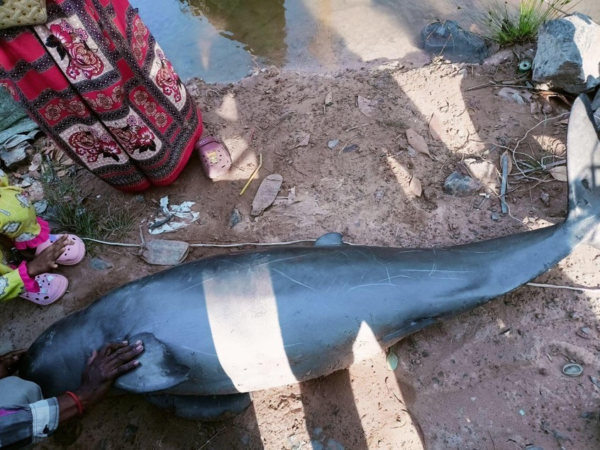
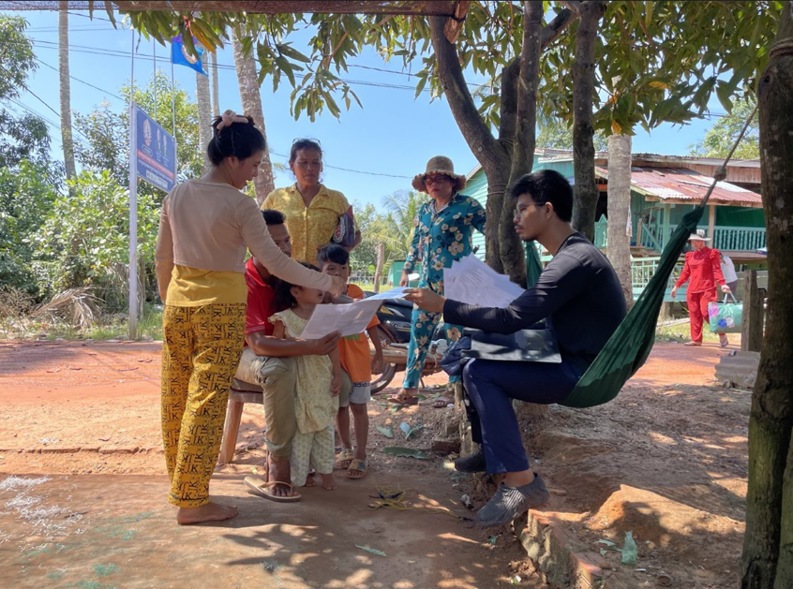
An Irrawaddy dolphin that was caught in a fisher’s net in Kampot province, Cambodia
A bycatch interview being conducted with a fisher, Koh Kong Province, Cambodia
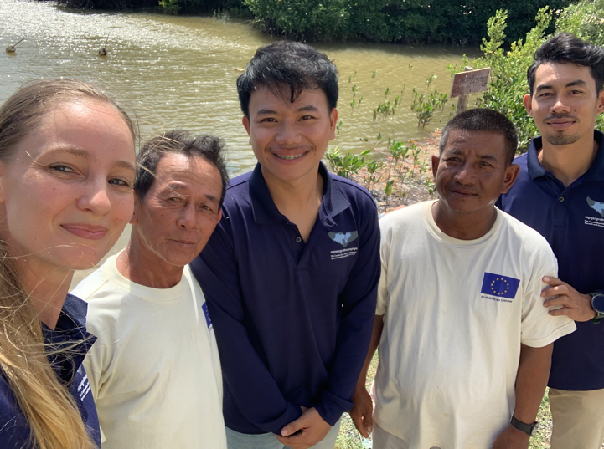
Appendix B
The CMMBSN team and Lead Community Responders at Kep Thmei Fishing Community, Kampot
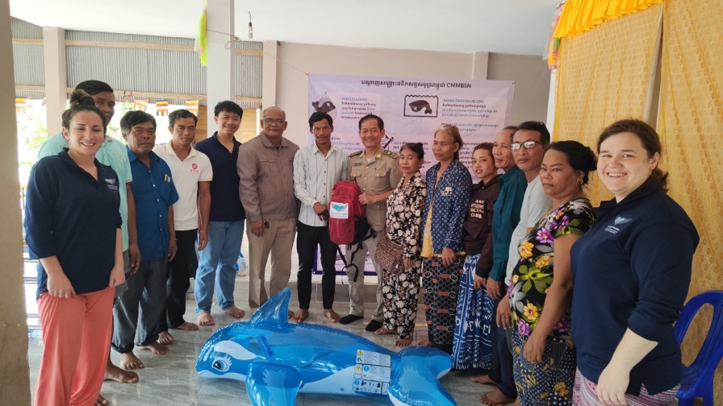

Handing out the backpack kits to the community in Sihanoukville province
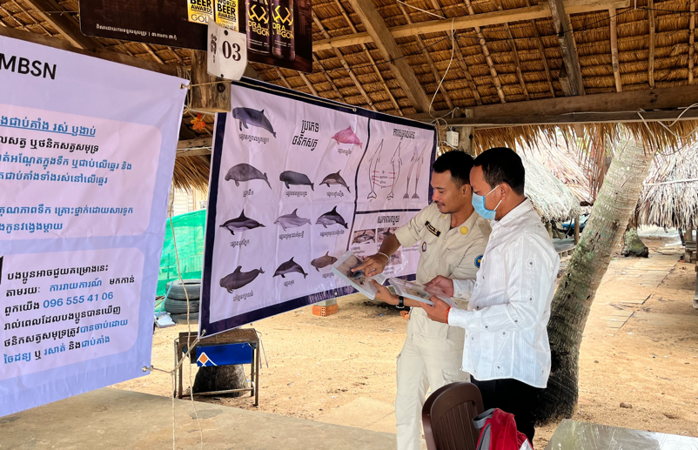
A fisheries officer and community committee member doing marine mammal identification, Angkaol Fishing Community in Kep province

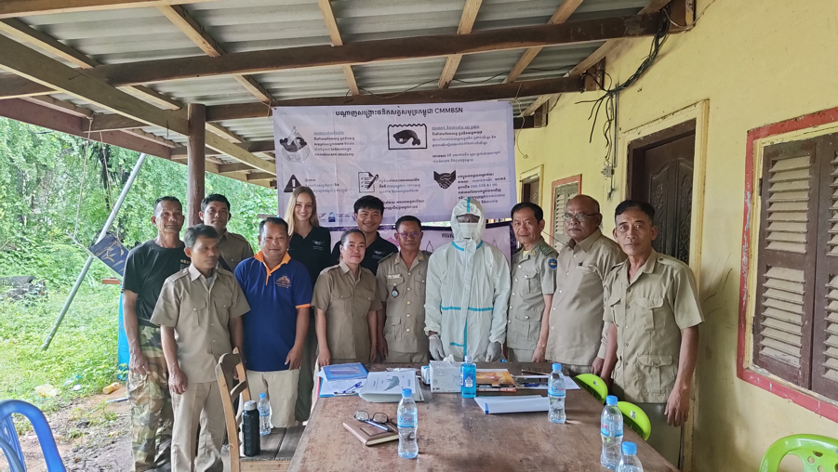
CMMBSN training at Ka Pea Prei Lech Terk Samrong Jong Ou Fishing Community in Sihanoukville
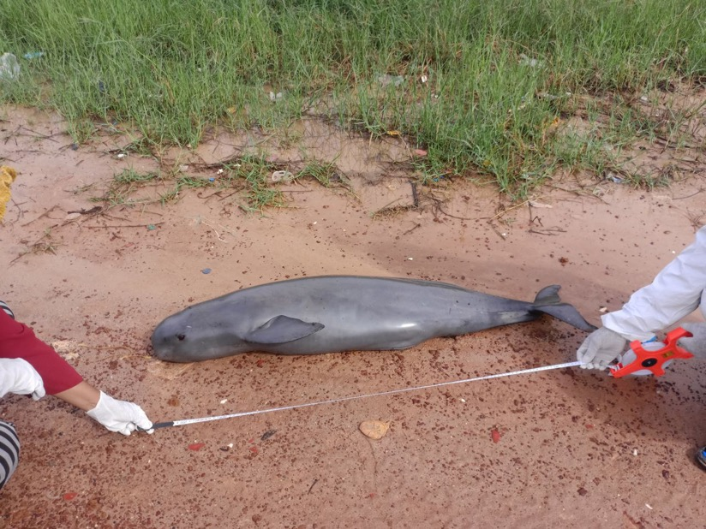
Bycatch of an Indo-pacific finless porpoise (Neophocaena phocaenoides), Kampot, Cambodia
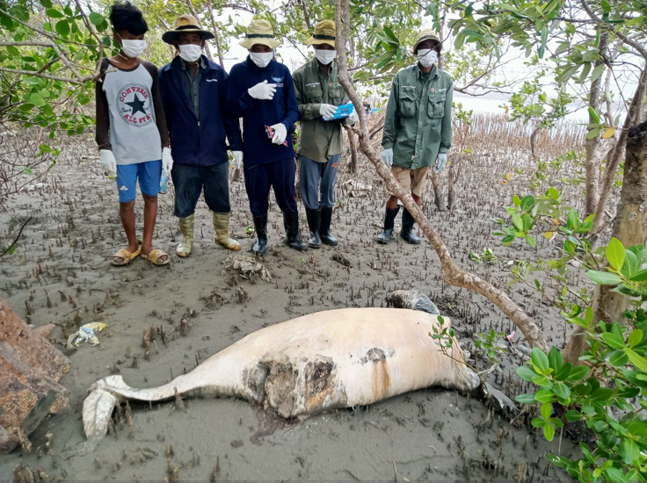
A stranded Dugong (Dugong Dugon), Kep, Cambodia
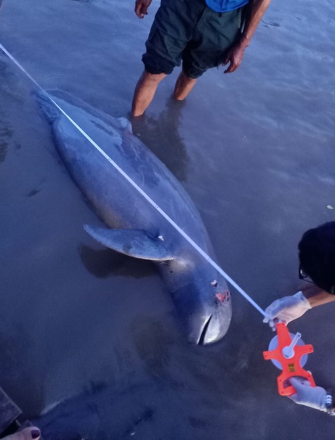
Stranded Irrawaddy dolphin (Orcaella brevirostris) at Prey Nob 2 Fishing Community, Sihanoukville
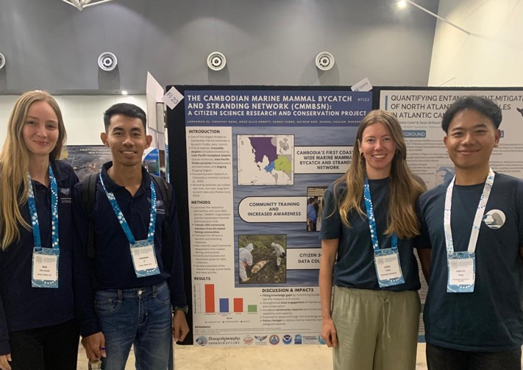

The KOL team at The Society of Marine Mammalogy Conference 2024 presenting the CMMBSN poster (left to right: Rose Ellis Arnett, Lokkaman El, Sarah Tubbs, Chhayhy Heng)
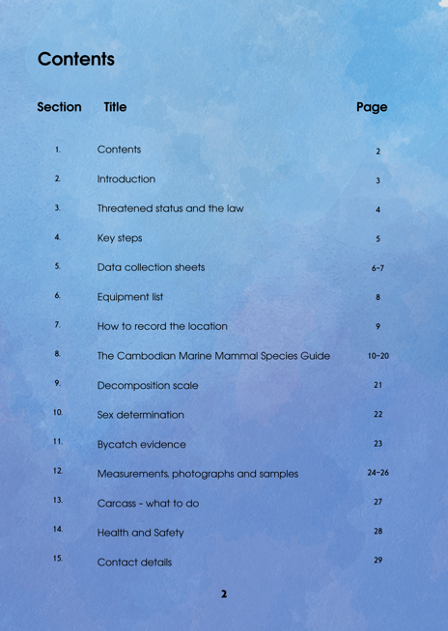
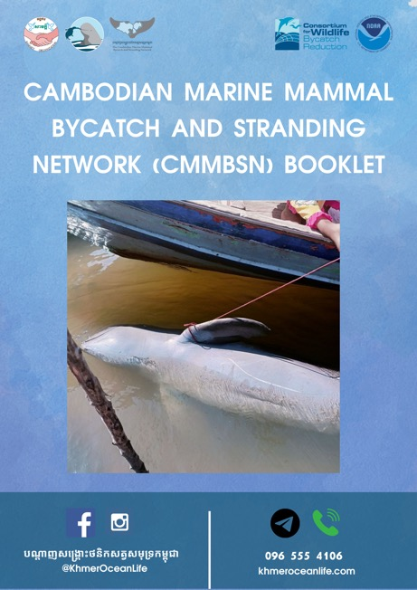

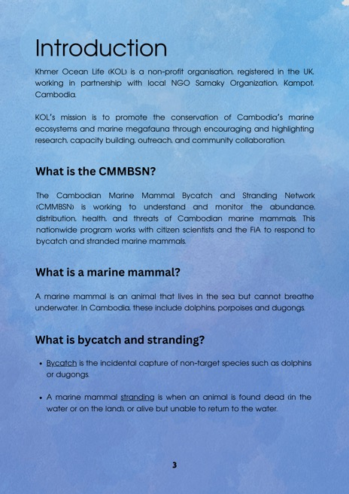
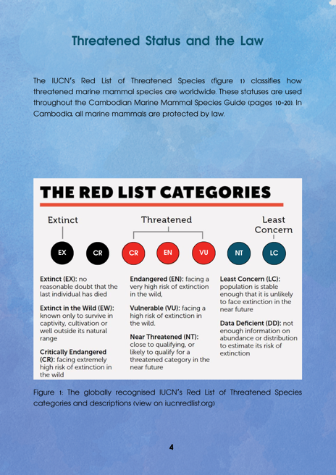

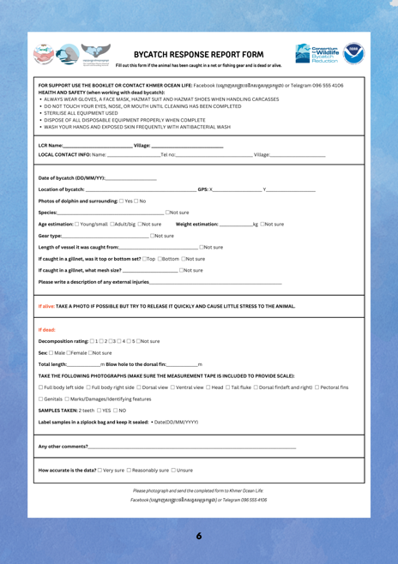
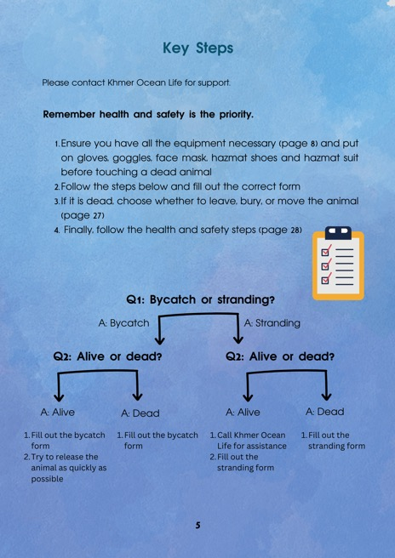

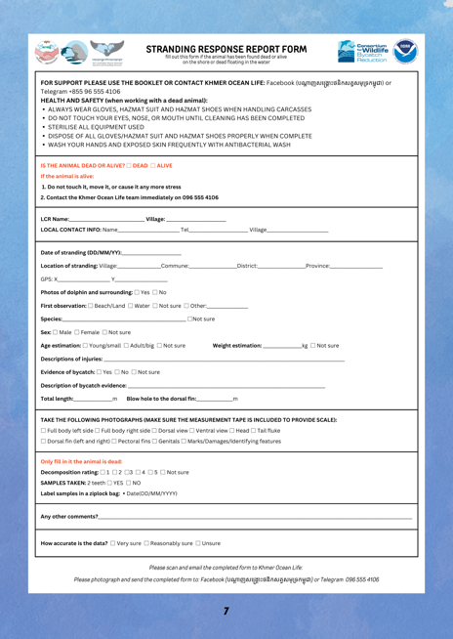
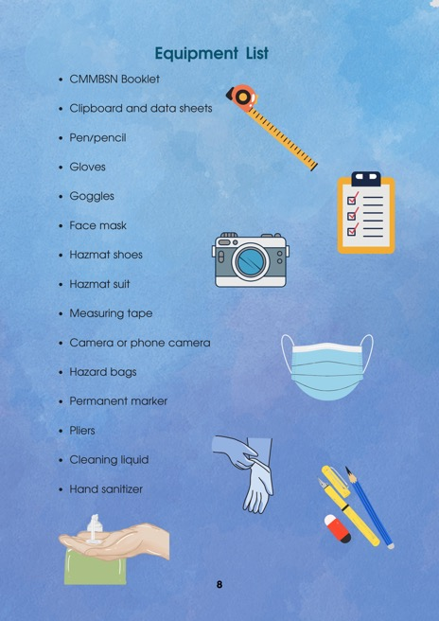

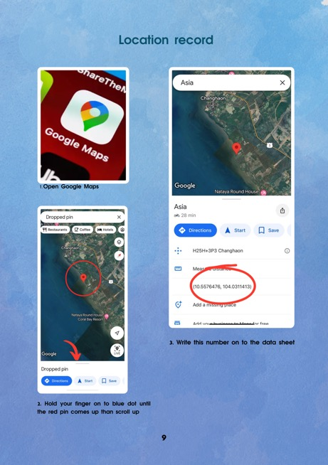
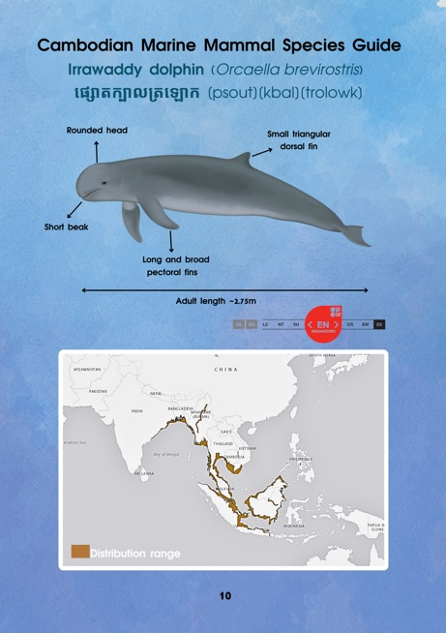

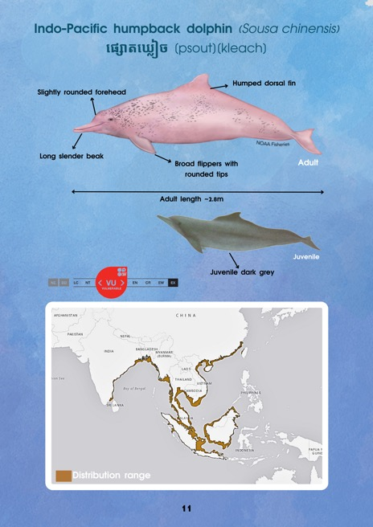
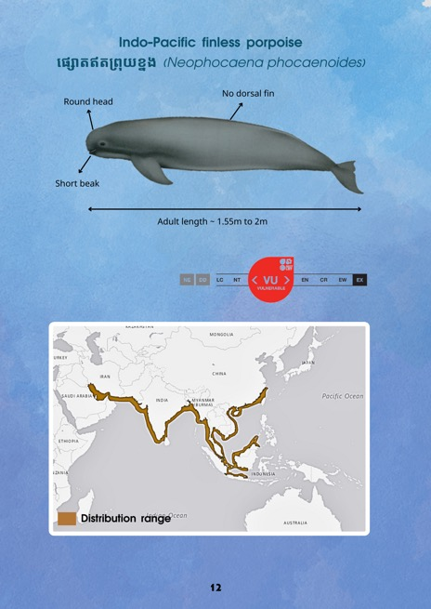

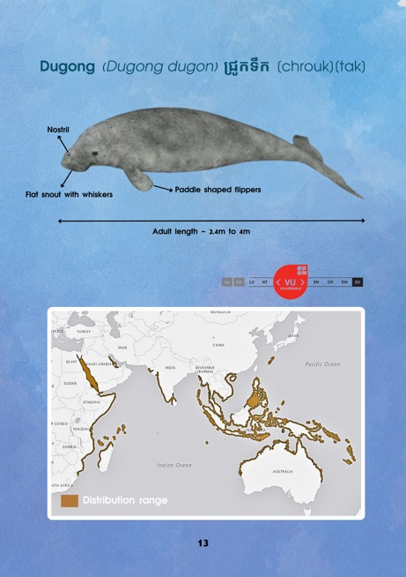
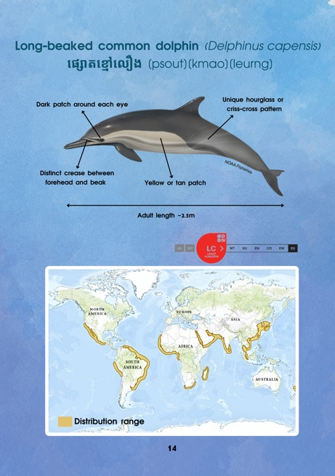

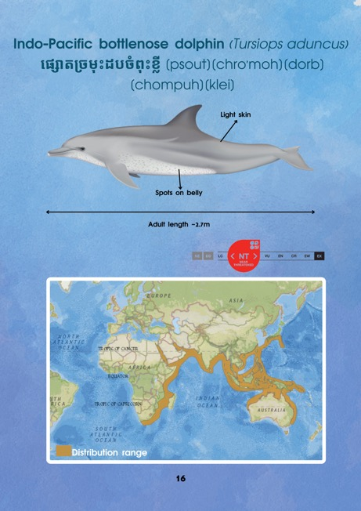
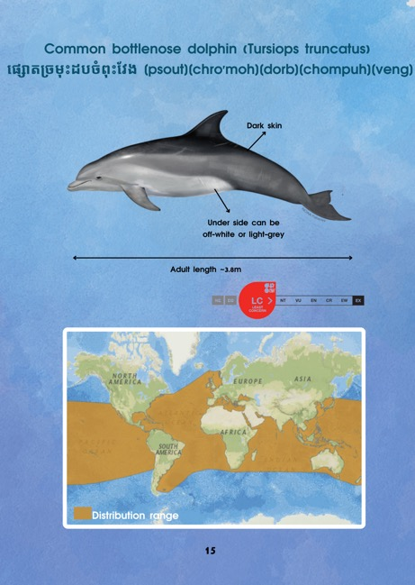

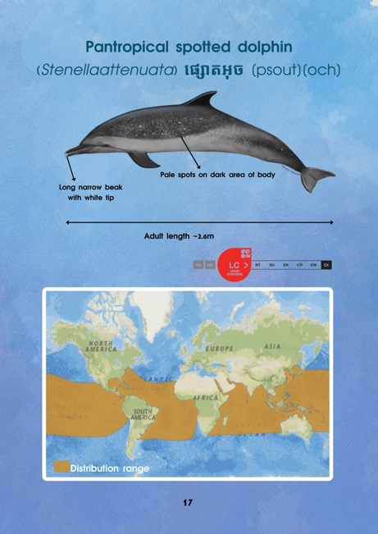
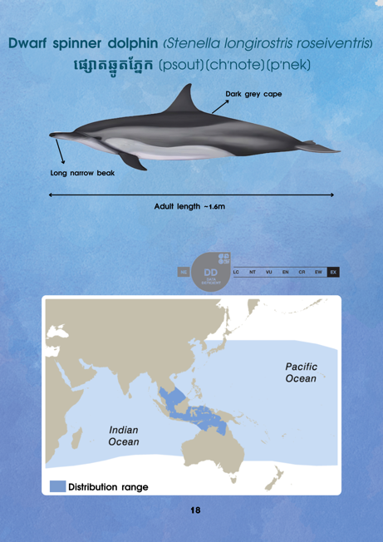

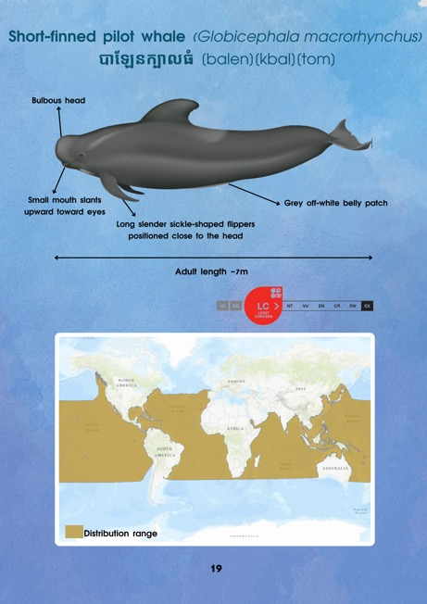
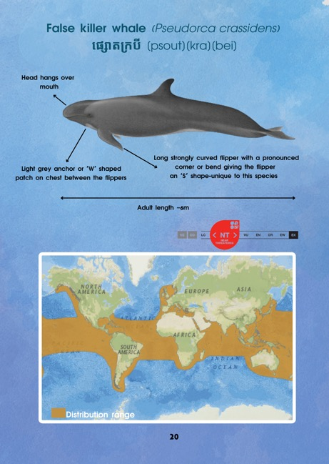

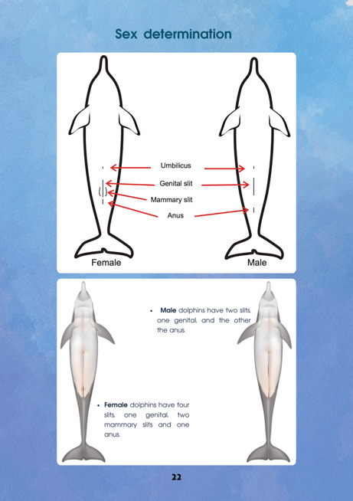
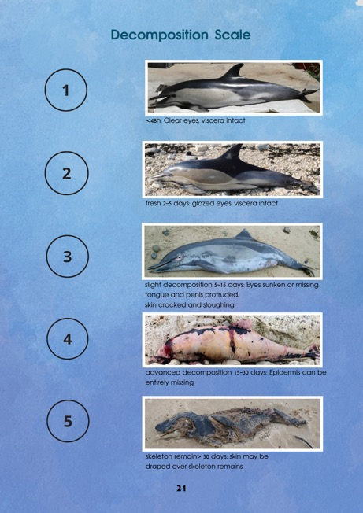

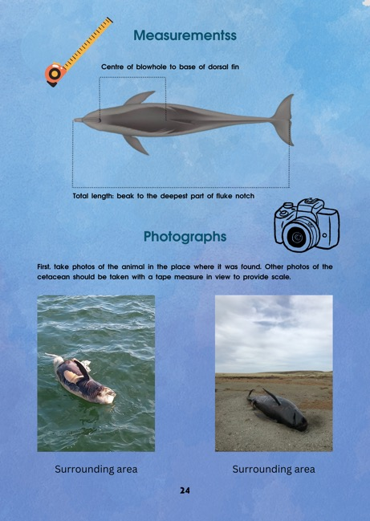
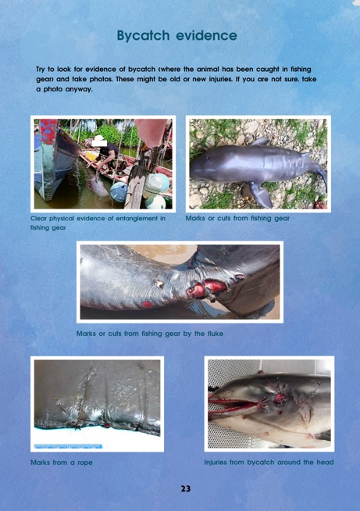

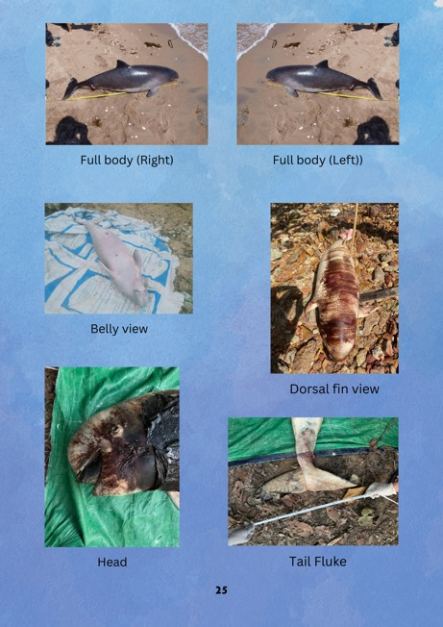
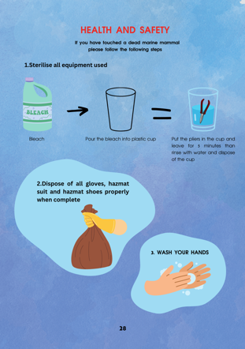
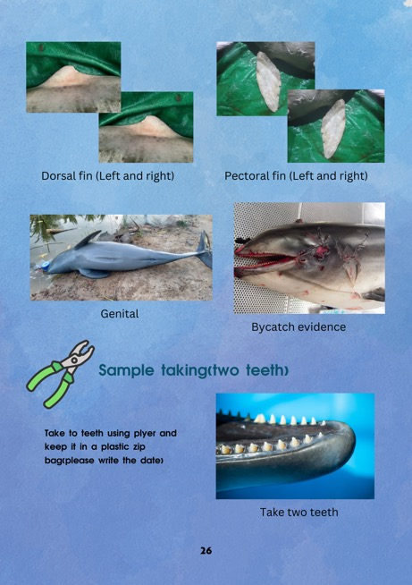
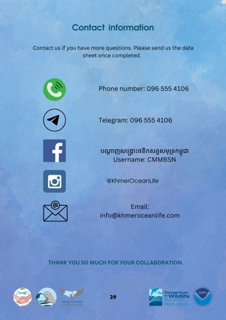
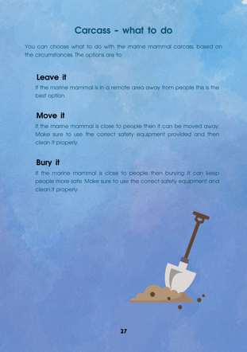

Cambodian Marine Mammal Bycatch and Stranding Network (CMMBSN) Booklet page 1-29

